### Analytics In Health Monitoring System Based On IOT

**TABLE OF THE CONTENT:-**

**1. INTRODUCTION**

**1.1 Objectives**

**2 Methodology**

**3 THEORITICAL ANALYSISS**

**3.1 Block diagram**

**3.2 Hardware/software designing**

**4. PYTHON CODE**

**5. RESULT**

**6. UI OUTPUT**

**7. ADVANTAGES & DISADVANTAGES**

**8. CONCLUSION**

**9. FUTURE SCOPE**

**1.INTRODUCTION:-**

Health is one of the global challenges for humanity. In the last decade the healthcare has drawn considerable amount of attention. The prime goal was to develop a reliable patient monitoring system so that the healthcare professionals can monitor the patients, who are either hospitalized or executing their normal daily life activities.

Recently, the patient monitoring systems is one of the major advancements because of its improved technology. Currently, there is need for a modernized approach.

In the traditional approach the healthcare professionals play the major role. They need to visit the patient’s ward for necessary diagnosis and advising. There are two basic problems associated with this approach. Firstly, the healthcare professionals must be present on site of the patient all the time and secondly, the patient remains admitted in a hospital, bedside biomedical instruments, for a period of time. In order to solve these two problems, the patients are given knowledge and information about disease diagnosis and prevention. Secondly, a reliable and readily available patient monitoring system (PMS) is required. In order to improve the above condition, we can make use of technology in a smarter way. In recent years, health care sensors along with raspberry pi play a vital role. Wearable sensors are in contact with the human body and monitor his or her physiological parameters. We can buy variety of sensors in the market today such as ECG sensors, temperature sensors, pulse monitors etc. The cost of the sensors varies according to their size, flexibility and accuracy. The Raspberry Pi which is a cheap, flexible, fully customizable and programmable small computer board brings the advantages of a PC to the domain of sensor network. In our system we are measuring patient’s parameters (ECG, temperature, heart rate, pulse, etc) with different available sensors. These sensors collected data i.e. biometric information is given to raspberry pi and then it is transferred to server.

1.1 **objectives:-**

1.Internet of Things (IoT) is the emerging technology, which contains huge amount of smart object and smart devices connected to the internet for communicating with each other.

2. In this project to analyze and compute the patient health we are using Raspberry Pi, which is the heart of this project.

3.These smart devices are used to collect temperature, blood pressure, sugar level, heartbeat, lung and respiration information etc., which are used to evaluate the health condition of the patient.

4.The final results are displayed on the android device, on web server and also the results are sent to the user through SMS.

5. These data results can be stored in data base centre which can be invoked from remote location at any time in an emergency case of patient without delaying the time.

6.This project may play vital role in saving the patient life at emergency time since “Time is life”

**2.Methodology:**

1. Patient level system

2. User level system

In this project we have temperature, blood pressure, ECG and heart beat readings which are monitored using Raspberry Pi. These sensors signals are send to Raspberry Pi via amplifier circuit and signal conditioning unit (scu), because the signals level are low (gain), so amplifier circuit is used to gain up the signal and transmit the signals to the Raspberry Pi.

Raspberry Pi is a Linux based operating system works as a small pc processor system. Here patients body temperature , blood pressure , ECG and heart rate is measured using respective sensors and it can be monitored in the screen of computer using Raspberry Pi as well as monitoring through anywhere in the world using internet source. The proposed method of patient monitoring system monitors patient’s health parameters using Raspberry Pi. After connecting internet to the Raspberry Pi it acts as a server.

Then the server automatically sends data to the website. Using IP address anybody can monitor the patient’s health status anywhere in the world using laptops, tablets and smart phones. If these parameters goes abnormal it will automatically sends alert SMS to the doctors and relatives.

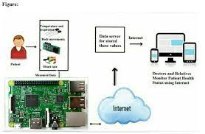

Figure:- Methodology of PHMS using IoT Devices.

**3 THEORITICAL ANALYSIS:-**

**3.1Block Diagram:**

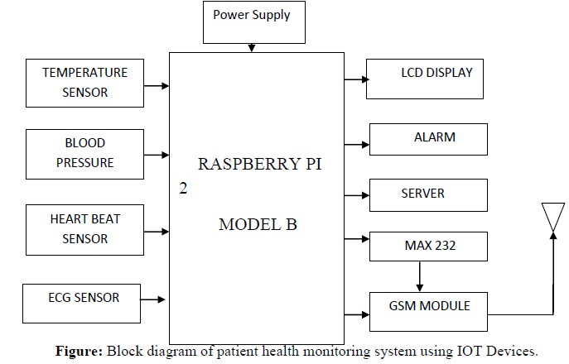

**3.2 Hardware And Software Requirement:-**

**==> Hardware requirements:**

a.Raspberry pi 2 model B

b.LM 35 temperature sensor

c.Heart Beat and Blood Pressure sensor

d.A to D convertor (MCP 3202)

e.ECG sensor

f.LCD Display

g.Alarm

h.MAX 232

j.GSM Module

k.Wi-Fi Dongle

**==>Software requirements:**

1.Raspbian OS

2.Python IDLE

3.Server (ThingSpeak)

**4.PYTHON CODE**

import wiotp.sdk.device

import time

import random

myConfig = {

"identity": {

"orgId": "ci6mm1",#place you're crednetials

"typeId": "iotedevice",

"deviceId":"1008"

},

"auth": {

"token": "7569767364"

}

}

def myCommandCallback(cmd):

print("Message received from IBM IoT Platform: %s" % cmd.data['command'])

m=cmd.data['command']

client = wiotp.sdk.device.DeviceClient(config=myConfig, logHandlers=None)

client.connect()

while True:

temp = round(random.uniform(99.9,105.2), 2)

pulse=random.randint(65,80)

bp=random.randint(120,140)

myData={'temperature': temp,'pulse':pulse, 'Blood_Pressure':bp}

client.publishEvent(eventId="status", msgFormat="json", data=myData, qos=0, onPublish=None)

print("Published data Successfully: %s", myData)

client.commandCallback = myCommandCallback

time.sleep(5)

client.disconnect()

#*dont connect to ibm watson simulator*#

**5.RESULT:-**

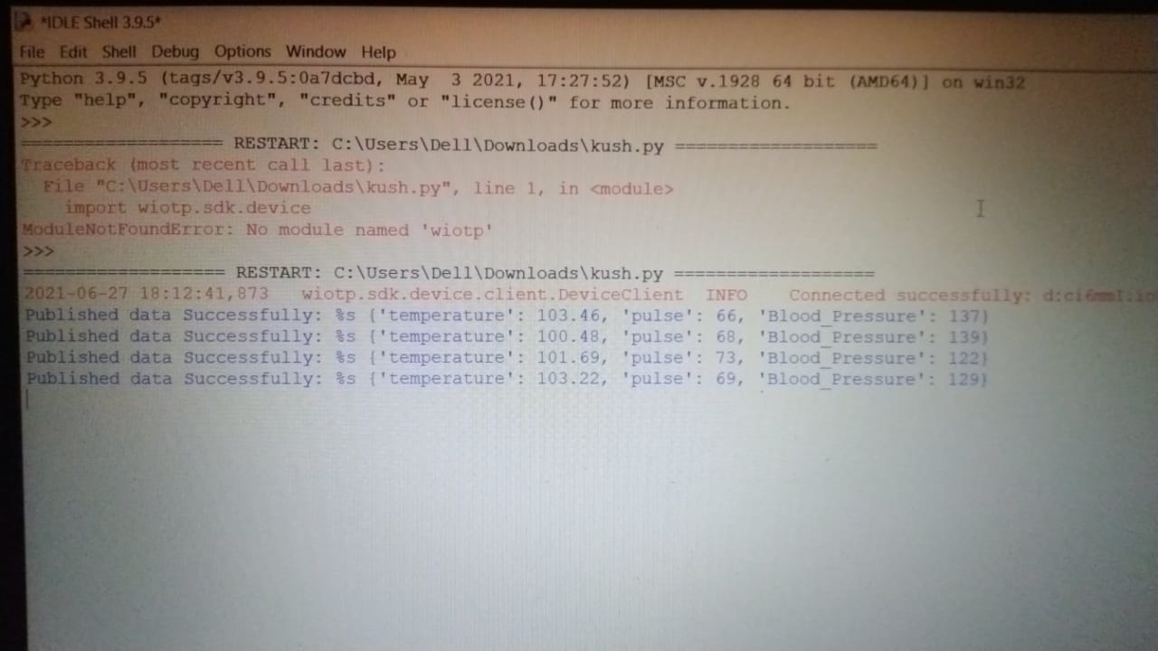

### **6.UI OUTPUT:-**

### 

### **7.Advantages of IoT in healthcare**

The ‘all-consuming’ connection of health devices and data centralization brings many significant benefits to the table, such as:

* All-around technological enhancement. Rendering hospital visits unnecessary, passively accumulating and deeply analyzing important health data, etc. We’ve already pondered on all these advanced tech capacities galore enough. The IoMT provides space for fantastic long-term innovations.
* Cost savings. One of the greatest advantages of IoT in healthcare is that efficient autonomous systems will cost less to manage and ‘employ’ in the long run. Things are even better when it comes to patient cost savings due to fewer hospital journeys as well as accelerated diagnostics and treatment.
* Accessibility. Doctors can view all the necessary data on command and check real-time patient conditions without leaving their office.

### **Disadvantages of IoT in healthcare**

Alternatively, some downsides that come along with the massive implementation of the IoT in healthcare include:

* Privacy can be potentially undermined. As we’ve already mentioned, systems get hacked. Lots of attention will need to be focused on data security, which requires significant additional spendings.
* Unauthorized access to centralization. There is a chance that dishonest interlopers may access centralized systems and realize some cruel intentions.
* Global healthcare regulations. International health administrations are already issuing guidelines that must be strictly followed by governmental medical establishments integrating the IoT in their workflow. These may restrict possible capacities to some extent.

**8.Conclusion**:

As health care services are important part of our society, automating these services lessen the burden on humans and eases the measuring process.

Also the transparency of this system helps patients to trust it. When threshold value is reached, the alarm system that consists of buzzer and LED alerts the doctors and he can act more quickly.

The objective of developing monitoring systems is to reduce health care costs by reducing physician office visits, hospitalizations, and diagnostic testing procedure. The GSM technology helps the server to update the patient data on website. Many further improvements can be made in our system to make it better and easily adaptable such as adding more advanced sensors. The biometric information of the patient which is stored and published online can be given to scientists and researchers of medical fields to analyze the value and find patterns or for other research work. To simplify the hardware and reduce wiring we can use wireless sensors.

**9.Future Scope:**

According to the availability of sensors or development in biomedical trend more parameter can be sensed and monitored which will drastically improve the efficiency of the wireless monitoring system in biomedical field.

A graphical LCD can be used to display a graph of rate of change of health parameters over time. The whole health monitoring system which we have framed can be integrated into a small compact unit as small as a cell phone or a wrist watch.

This will help the patients to easily carry this device with them wherever they go. In addition with medical application we can use our system in industrial and agricultural application by using sensors like humidity sensors, fertility check sensors, etc.